

Created by Mr. Lors
  - Our School Motto:
Respectful, Responsible, and Ready to Learn, We are 184.

The Newport News

Parent Newsletter

We are the Lions

Welcome To Our Monthly Newsletter

In this issue
The 3 Rs Defined
The Principal’s Message
Spanish Class Letter to Parents by Mr. DGiacomo

Computer Technology Letter to Parents by Mr. Lors
Art Class Letter to Parents by Mr. Wilson
Class 501 Letter to Parents by Ms. Marshall
Introduction
The School
Motto
Message From
our Middle
School
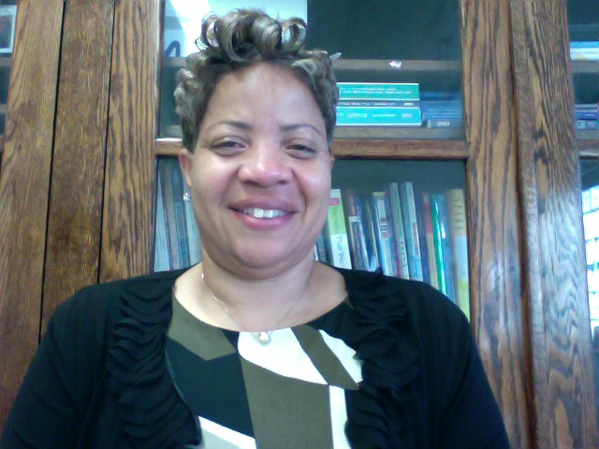

Welcome to the 2014-2015 school year which is expected to be exciting, challenging and meaningful. By now I have met most of you, however, if I have not I look forward to meeting you throughout the school year.

As the new interim acting Principal at PS/IS 184 I come with over 20 years of experience as a teacher and administrator with the NYC DOE. Over the years I have maintained high expectations and look forward to ensuring that all of the students at PS/IS 184 are provided with a well rounded educational experience. As your child is exposed to a rigorous and challenging curriculum I will seek to implement exposure to the arts, as well as, S.T.E.M related activities.

I look forward to a productive, positive and rewarding school year.

Sincerely,

Lisa Linder
Principal,I.A.
The Principal’s Message
The School Motto: “The 3 Rs Defined”
Respectful: We will respect ourselves, each other and our school.
Responsible: We are responsible for trying our best.
Ready To Learn: We will be ready to succeed.

Volume 1
Issue 1, September 30, 2014
We are 184

Message From Our Middle School
Spanish Class Letter To Parents

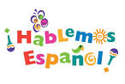
Dear Parents and Guardians,
I wanted to let you know what we have been doing in Spanish class, and what we will be covering in the near future. So far your child has been working on Spanish and English cognates (words like clase / class, teléfono / telephone, etc.), the Spanish alphabet, and command vocabulary to help us speak more Spanish in the classroom. Our next unit will cover introductions, common questions, and expressing basic feelings, so your child will be practicing speaking the language a lot and using it in a dialogue writing project.
I also wanted to make you aware of an internet resource to help your child learn and practice their Spanish vocabulary at home. They can create an account at www.quizlet.com and then find me by typing Sr_DiGiacomo into the search bar. You can also contact me with any questions or concerns at:
mdigiacomo@schools.nyc.gov.

Computer Technology

Dear Parents and Guardians,
I am the Technology teacher for your child this school year. I would like to share with you what our wonderful Middle School students have been doing in Technology class since the beginning of the September.
The 6th grade has learned about computer hardware and has used Appleworks 6 drawing application program to draw and label the parts of computer hardware. The 7th grade worked on an Autobiography project. They learned the basic of formatting, pulldown menu skills, borders, shading, header and footer skills. They also learned how to use multimedia Photo Booth to take a picture and insert it into their Microsoft Word page document.
8th grade students worked on Technology current events assignment where they used a specific browser to research and find out about new Apple Gadgets. They also reviewed the basics of formatting, pulldown menu skills, borders, shading, header and footer.
In our next unit we will be covering desktop publishing activities and multimedia. We would like to hear from you. If you want to know how child is doing please contact me at: jlors@schools.nyc.gov

PS/IS 184 Art Class

Greetings Parents:
I consider it an honor to be your child’s art teacher. We are already working with clay and painting in class. As these materials can stain- please send along an old shirt for your child to wear to art class. Also we will be starting our after school art club next week. The club will be from three to four o’clock on Fridays. (Have your child see me for permission slips).
In addition middle school children who wish to grow artistically can see me during the third lunch period to develop their portfolios or work on special projects 9be sure to ask me for a pass).

Sincerely
Jay Wilson, Art Teacher.

We have completed the first month of school and we are well underway with the students being immersed in the Connected Math Program. Sixth grade students have been vigorously working on factors and multiples. It would be a great help if parents reviewed the multiplication facts with your child.
Seventh graders are currently developing their skills in the real number system. Be sure to review the rules for adding and subtracting integers with the students.
Eighth graders are working on creating and evaluating expressions. Parents are urged to make sure their students have complete and correct notes.
All students should review their notes nightly to ensure academic success and mastery of that particular skill.
Look for upcoming dates for which the baseline math test will be administered. Please continue to partner with us to ensure a successful school year.

News Letter contribution- Science
The Science Department welcomes all families to a new and exciting academic year.
We stand behind the philosophy that “all children can learn” and so it is our goal to provide engaging and rigorous science instruction to all our students in a loving and caring environment that will afford them an opportunity to succeed.
In grades k-5 students will be exposed to fun and exciting lessons that will help them to uncover concepts in Life Science, Earth Science and Physical Science. Their learning will take place both inside and side of the classroom and so there are many field trips that your child/children will be invited to participate in throughout the year. The middle school years (6-8) are a time for your child to work collaboratively with others in many exciting and rewarding experiences. During the school year we will build upon the foundation of elementary science through inquiry based lessons in a laboratory setting. One of the highlights for this school year will be our School’s Science Fair. As soon as this event is planned it will be communicated to you.
We are off to a great start and we encourage you to have conversations with your child/children to find out about the exciting things they are learning and ways in which you can assist them. We are looking forward to working together with you to help your child meet the challenging requirements for the school year.
Science Department
Mrs. A. Greenfield (Elementary)
Mrs. T. McKie (Middle School)

We are 184

Message From Our Middle School

Kindergarten

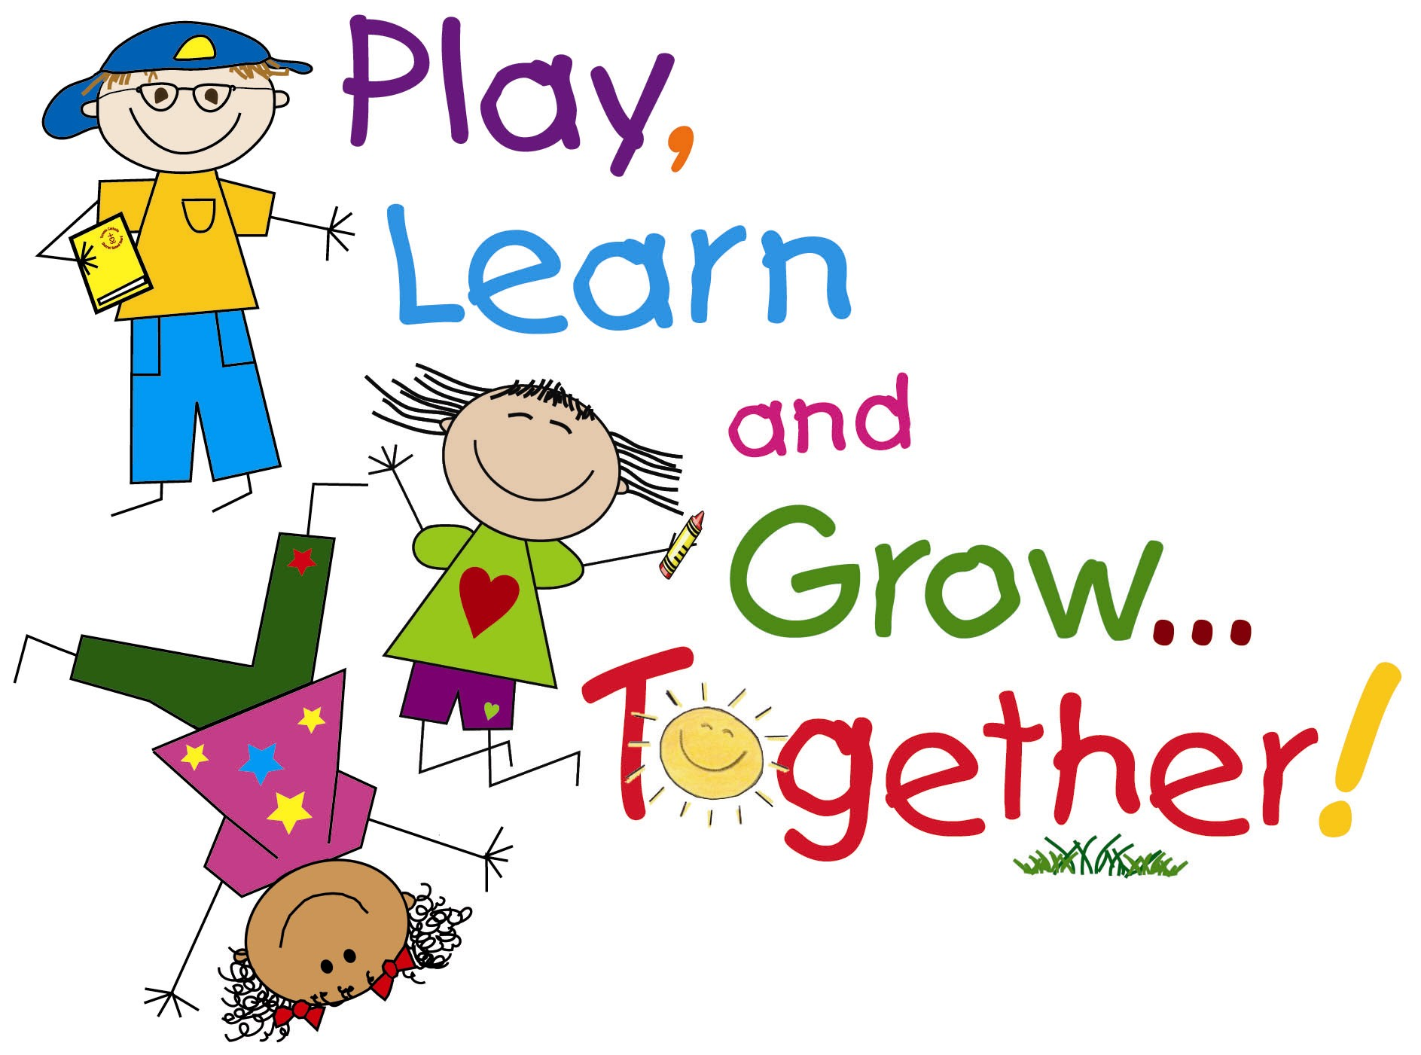

The kindergarten team will be working on the following items for the month of October:
Letter & sound recognition for the letter of the week
Books being read are: Make a Way For Ducklings & A House For Hermit Crab
In Mathematics, our focus is number concepts emphasizing on 1 to 10
Student s will also explore the Fall season
Friendly Reminders:
Please assist your child in completing homework nightly. Please work on self-sufficiency skills like tying shoelaces and buttoning/unbuttoning coats, jackets, pants, and zippers.

C. Njoku
A. Grayfer
I. Gajadar
T. Rousseau

Kindergarten Teachers

Prekindergarten

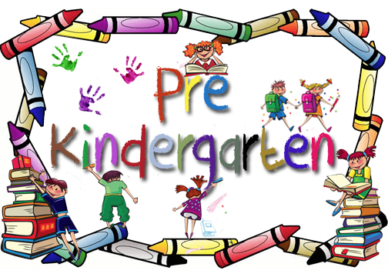

Welcome to Pre-K!! We are starting off the school year with such excitement. We are delighted to have visiting our Pre-K classrooms the Letter People. In our classrooms the Pre-K children will learn by doing. The Letter People will get children doing by being part of the Pre-K classroom family. These special friends will get our children talking, moving, interacting, experimenting, drawing, counting, and ultimately ready to read and write. We love to help your child learn. We know you do, too. We look forward to working with you and your families. It's going to be a wonderful year!

Educationally yours,
Prekindergarten Teachers and Educational Assistants

Class 501 Letter to Parents

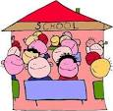

We are off to a strong start! We invite you to get on board to help your child be successful.

As our partners in education, you are invited to join the 5th grade teaching team of Ms. Marshall, Ms. Hadley, and Ms. Lewis for a student-parent workshop on Wednesday, October 15th from 2:45-3:30 in room 406. We will be doing a math lesson that is aligned to the common core standards. This will better prepare your child for the 2015 New York Math Exam. We look forward to seeing you as we continue to help your child realize his/her full potential.

J. Chase-Marshall
5th Grade Teacher
We are 184

Message From Our Elementary School
Continued

2nd Grade

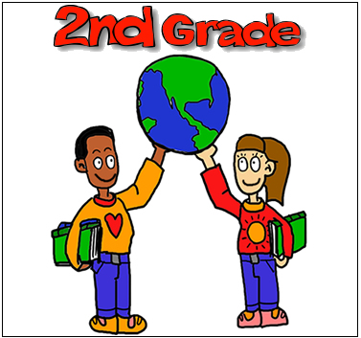

We are off to a strong start! We invite you to get on board to help your child be successful.

As our partners in education, you are invited to join the 5th grade teaching team of Ms. Marshall, Ms. Hadley, and Ms. Lewis for a student-parent workshop on Wednesday, October 15th from 2:45-3:30 in room 406. We will be doing a math lesson that is aligned to the common core standards. This will better prepare your child for the 2015 New York Math Exam. We look forward to seeing you as we continue to help your child realize his/her full potential.

J. Chase-Marshall
5th Grade Teacher

1st Grade

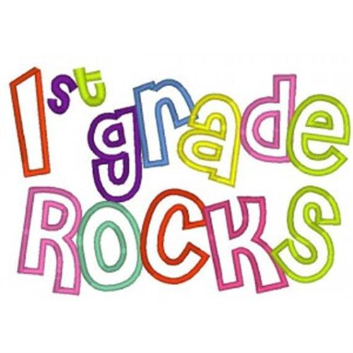

WELCOME BACK

- Homework is given every night
- Read with your child for 20 minutes
- Check out what’s happening this month at your local library
- This month in ELA, the students are learning about friendship and the literary elements include title, author, genre, characters, setting, and beginning/middle/end
- This month in mathematics, we are learning addition with emphasis on common vocabulary found in the strand including: addition sentence, is equal to (=), plus (+), and sum
- This month’s upcoming trip is to Prospect Park on October 24th

Ms. Morgan
Ms. Warner
Ms. Harwell

3rd Grade

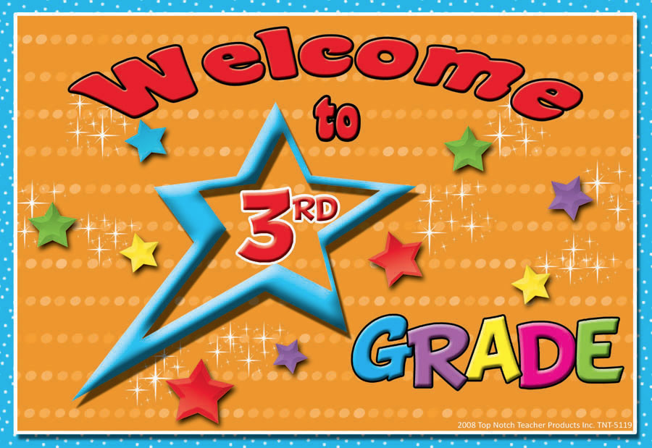

We are off to a great beginning. Just a few reminders: check your child’s homework nightly and all children are required to read nightly and log in the information on their reading log. We’ve just completed Unit 1 in out GoMath, which covers addition and subtraction within 1,000. We will be moving onto Measurement and Data for Unit 2. In ELA, the children are enjoying our fictional stories about two young scientists who solve cases as science detectives. Our Social Studies unit focuses on geographic features and cultures around the world. Information about their take home project will be coming soon. Please read all fliers and notices that come home in your child’s folder.

Ms. Virgona

Message From Our Elementary School
We are 184

Message From Our Elementary School

Technology



This year for the elementary school technology classes, we will be learning to code. What is code? That’s the fun part! The students will be actually creating their own games by programming computers with code.org. Here, students learn the basics of Computer Science with drag and drop programming through game-like, self-directed tutorials. From Kindergarten up to 3rd grade, students will work with skill appropriate modules that all culminate in creating unique games. This program is aligned with the common core standards for both Mathematics and ELA. Best of all… IT IS FREE!! Feel free to learn with your child by visiting www.code.org

R. Terrell
Elementary Technology

Italian American
Civil Rights League



PS 184 Afterschool CLUBS for students 6th – 8th grades, ROCKS!!!
The students are in involved in fun and innovative activities, such as GIRLS Empowerment club, BIG Brother club, Homework Club, Math & Science Club, Multimedia Club, Basketball Club, Chess Club, Performing Arts Clubs, Dance, Cheerleading & Step club and so much more!!
The students have the opportunity to go on collaborative and exciting field trips to Sony Technology Wonderlab, New Rock City, and local Museums to study the history of our surroundings, just to name a few.
The focus of these trips and activities is to instill leadership and teambuilding skills through recreation and academics, to prepare our students for a better tomorrow. We would love for you to register your child into the program and be a part of the difference we are making in the lives of students here at PS184.
For more information on how to register, please contact Ms. Nicole Williams, in office 156 or 718- 495-7775 ext. 1560 or email: iacrlnwilliams@aol.com
REGISTER NOW!!!

4th Grade

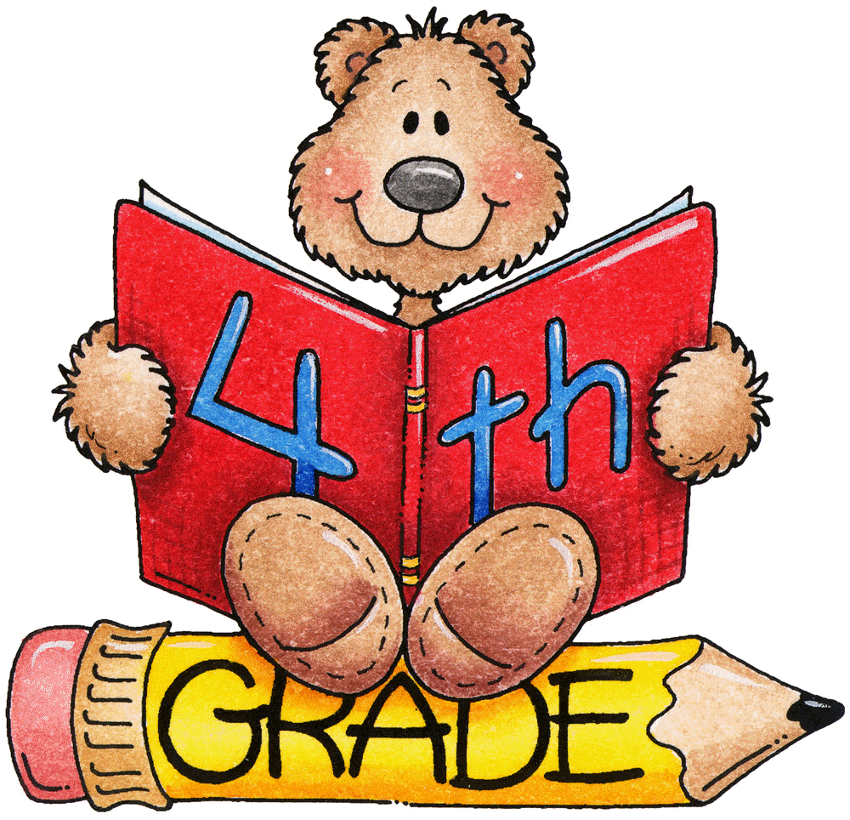

This month in the fourth grade we are working on an amazing book in ELA, entitled the Tarantula Scientist. It is all about a scientist named Sam. Sam spends his days either in his laboratory or crawling around the floor of the rainforest. However, no matter where he is, he is playing with spiders, and usually those spiders are tarantulas. Students have gotten into the book and are now working on creating short biographies of their own on a scientist who’s had a lasting effect on the world that we live in.
In math we are starting Unit 2 of our o-Math curriculum. That means that we will be working on multiplying. We will be multiplying1 and 2-digit numbers with multi-digit whole numbers.
In Social Studies we are now beginning our unit on New York. This month, we will be learning about New York’s land features, such as its mountain ranges, rivers, lakes and oceans.
Ms. Young-Innis 4-401
Ms. Conway 4-419
Mr. Albrecht 4-402

We are 184

